Date of submission:
Member/Team:

Section 1: Artist Details

Name
Address
Telephone/s
Email
Website/blog (optional)

Artist Biography / Resume please keep this brief, a short paragraph will do

Payment Details (Add details below for your chosen payment method in BLOCK CAPITALS)
Preferred payment | BACS payment 𑂽 | PayPal 𑂽

Bank Account Details for BACS
Name on Bank Account:
Account Number: |  | Sort Code:

PayPal Details
PayPal email address:

Proceeds from artwork sales might be considered taxable income and income declaration is a responsibility of the artist. Guidance is available from the following organisations:HMRC helpline - 0300 200 3310; Citizens Advice; Tax Help for Older People; Taxaid.org.uk

Section 2: Artwork Information
Please make a copy of this section for each piece of artwork you are submitting

Title 1:
Medium: |  | Surface:
Dimensions (cm) | Height: | Width: | Depth:
Sale price | £ | Framed ⃞ | Unframed ⃞
Optional donation to SU (not using commission which is 35% for SU Members and 45% for non Members) | 50% ⃞ | 70% ⃞ | 100% ⃞
Artwork Images** | Provided by artist 𑂽 | To be taken by SU 𑂽

Delivered at location: Dalston 𑂽 Croydon 𑂽 Bristol 𑂽 N/A (kept with the artist) 𑂽
Pack and Post by: Artist 𑂽 SU𑂽

The work/s will be delivered to SU prior to it being advertised on the online shop | Yes | No
The artist will keep the work/s whilst it is advertised on the online shop | Yes | No

OFFICE USE | Product code: _________ Date artwork received ___/___/___  Location : ________________________________  Added to the inventory on date: ___________  Team member received/ added: __________
Listing start date | ___/___/___
Listing end date | ___/___/___

Artist statement / About the artwork:

CHECKLIST

Please ensure you have done the following:

𑂽 Completed all sections of the form
𑂽 Considered the postage costs and indicated clearly who is responsible for packing and posting and where the artwork is located
𑂽 Photographed the artwork in high resolution and saved the image files (jpeg) with your name as follows: FIRSTNAME_LASTNAME_TITLE
𑂽 Emailed of the images of the work to submissions@studioupstairs.org.uk
𑂽 󠀱Read and accepted the Artist Submission Terms & Conditions

TERMS & CONDITIONS

- Studio Upstairs (SU) provides a platform for artists at all stages of their career to promote and sell artworks through the gallery or online. SU retains its discretion to refuse artwork that is inappropriate.

- Artists must complete an Artwork Submissions form, sign and return it to the office.

- The proceeds from donated work will go towards supporting the core work of the charity. SU reserves the right on whether to accept any donation.

- The commission charged to the artist covers the marketing, administration and handling of the submitted work. The current (2022) commission for Studio members and team is 35%, for other artists 45%.

- All artwork must be original, not a copy of someone else’s work.

- SU will accept up to 6 images per SU member for online listings and up to 2 artworks for gallery display.

- The maximum size of work accepted for physical storage by SU is:

  - 2D: 100cm x 150cmx 5cm
  - 3D: 50cm x 50cm x 50cm

- Photography: when taking photographs of your artwork, use a white/ neutral background with good even light, ensure there are no obstructions or glare within the image.

Not acceptable  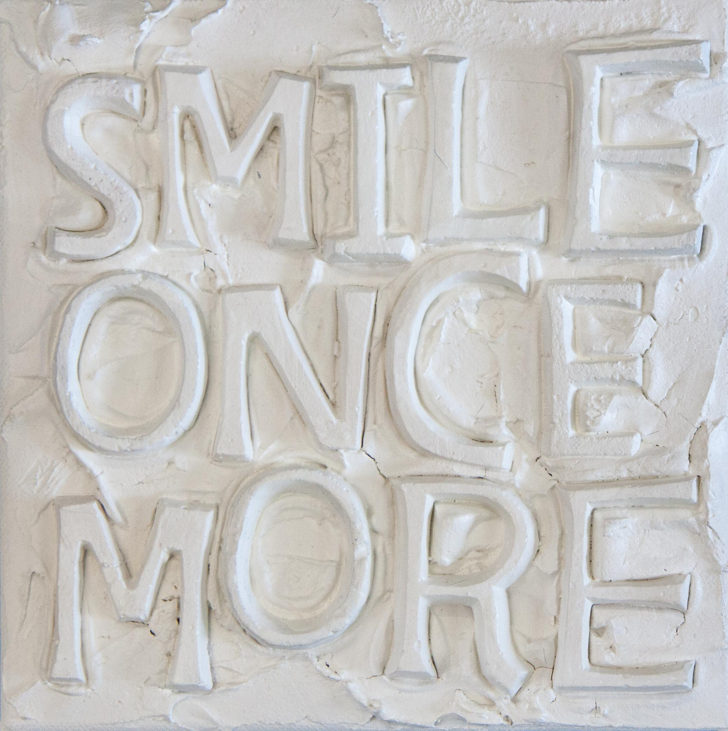  At an angle, low light, dark background, other items in image | Acceptable  Full image, no background, balanced light, clear detail

- All artwork to be displayed in the Gallery must be exhibition ready and prepared for hanging. 2D artwork without wire, string or mirror plates are not accepted. There should be no projections whatsoever from the back of the works, please ensure fixings on canvases are flat to the back of work.

- Works will be listed on the website and/or displayed in the gallery for 6 months or until the work is sold - whichever is first. If work is not sold after a period of 6 months, artists may be invited to re-submit new images.

- Artwork that is donated or stored at SU sites requires prior agreement - these artworks must be delivered to the Studio prior to being advertised on the website.

- Submitted artwork which is not sold online and not collected within the agreed period will be considered a 100% donation to SU.

- Payments:
  - Payment from the buyer will be made to Studio Upstairs.
  - The payment to the artist will be made by bank transfer, on the second Tuesday of the month. This payment will be calculated based on the final price of the artwork sold minus commission and with consideration of any delivery charges.

- Arranging delivery to the buyer if/when sold.
  - The cost of packaging and delivery will vary according to destination/weight and will be charged to the buyer by SU when the work is with SU.
  - When artwork is with the artist, the artist must arrange delivery to the buyer within 5 working days of the sale. The artist will receive back the full cost of delivery when the payment is made on the second Tuesday of the month.

- Artwork Collections
  - The artist would need to collect artwork not sold within two weeks of receiving notification from SU.
  - Uncollected work will incur storage charges of £5 per day and after one month will be disposed of as SU see fit.

- Every reasonable precaution will be taken in handling the work. Work should not be so fragile that shipment would potentially be harmful to the work or those handling it.

- SU will not be responsible for any loss, theft or damage. You are advised to arrange your own insurance.

- If any submitted artwork is sold elsewhere at any point during the 6 month listing period, it is the duty of the artist to inform Studio Upstairs immediately so that it can be removed.

By signing below you are accepting the Terms and Conditions outlined above.

Name: _________________________________________________________________

Signature: ________________________________ Date: _____________________

